ADTA-DAST 5900/5750.501: Applied Natural Language Processing
Project: System Requirement and Analysis
By:- Bhawana Rohile, Sarika Gaind, Aamir Omar

- Introduction and general description of the AI dialogue system.
The proposed AI-powered Dialogue System is an intelligent conversational bot that aims to simplify appointment scheduling functions in small healthcare centers. This is because in smaller healthcare centers, there are often high volumes of phone traffic, prolonged wait times, and fewer administrative staff. However, this often results in poor patient satisfaction and ineffective day-to-day business operation. To counter this problem in healthcare centers, our Dialogue System relies upon Natural Language Processing (NLP) and Dialogflow CX from Google Cloud.
Essentially, the system can be seen as a virtual front-end assistant that engages with patients 24/7. The system understands the intention of the patient, derives information like patient name, date of birth, clinic location, provider name, type of appointment, and appointment reason in a structured way, and helps patients follow the right procedure according to their needs. Whether the patient needs to schedule a new appointment, try to reschedule an appointment if the first attempt failed, or cancel the appointment due to some unforeseen circumstances, the agent deals with each situation through appropriately defined Dialogflow CX dialogues and pages.
The system launches all conversations from the default start flow and proceeds based on the intent classification of the interaction, such as scheduling, rescheduling, or canceling. The system directs each conversation based on the relevant significant flow after classifying the intent. The significant flow contains code represented in the form parameters to validate user inputs and display confirmation summaries step by step until the system indicates completing necessary information. The code in each flow aims to create or update an appointment. This code operates in the background like other system components.
The system architecture encompasses the use of a data model that involves patient data, provider data, and appointment data. The use of custom entity types together with system entity types such as dates and times enables the agent to understand the inputs from the users. The use of logic and confirmation pages provides users with necessary instructions in cases where users may enter unclear or incorrect data.
On the whole, the AI dialog system provides a scalable and effective alternative that not only mitigates administrative hassles but also optimizes patient satisfaction and automates the erstwhile manual process of scheduling. By integrating linguistic intelligence with workflow engineering, this system not only meets the requirements of small-scale clinical offices but also provides users with a seamless experience.

- Business, technical, and data requirements (HW 4)
Business Requirements:
The aim is to create a conversational AI that makes patients with existing registrations in the clinic be able to schedule their appointments or reschedule them or cancel them in an effortless manner. It will be a virtual assistant that can converse with patients in the manner of human conversations, making them reschedule or cancel appointments.
Patients can communicate with the AI at any given time that is convenient for them. The list of possible care providers and their clinics, as well as their availability at any given time, will be obtained for the patient to choose the appointment time that is most suitable for them.
If the patient wishes to reschedule or cancel an existing appointment, the AI will assist in this process by confirming the patient's identity and listing the available choices for them, making sure that this process occurs quickly and seamlessly. Overall, this process aims to limit any work for the clinic staff while at the same time giving the patient an easier and more convenient means of taking care of their healthcare needs.
Technical Requirements:
The conversational AI agent for patient scheduling will be built using Google Cloud's Dialogflow CX. The features offered by this platform, including flows, intents, routes, and pages, will be used to create a seamless and efficient booking process. Below are few of the major components which will be used for building the AI agent
- Flows:
The Flows will be created to define the high-level conversation structure. This will guide patients seamlessly through each stage of the appointment process, from initial inquiry to final confirmation. Separate flows will be created for each task to ensure clarity and smooth transitions between stages. Below flows will be created for each process
- Default Start Flow – To initiate the conversation with the patient and gather input on what they want to do: schedule, reschedule, or cancel an appointment.
- Schedule Appointment – To handle the process of booking a new appointment for the patient.
- Reschedule appointment – To handle the scenario where a user wants to reschedule an existing appointment.
- Cancel appointment – To allow the patient to cancel an existing appointment.

- Intents:
The Intents will be used to capture user goals based on their input such as new appointment scheduling, rescheduling, or cancelling. Specific Intents will handle a specific scenario and trigger the right response to the patient or route it to the appropriate page.
- Routes:
Routes will be used to direct the conversation based on patient input, ensuring patients are taken to the relevant page or flow. Routes can handle transitions such as moving from a slot selection page to a confirmation page, or from a scheduling flow to a rescheduling flow.
- Pages:
Pages will be created to handle the individual steps in the conversation. Each page handles a task like collecting patient info, displaying available slots, or confirming the booking. Pages ensure a structured conversation by prompting users for details and validating responses.
- Entity Types and Entities:
There are different categories of information which will be received from the patient for the tasks he is doing conversation with the AI agent. Different entities will be created to extract the required information from the patient at various stages of the conversation. The system entities such as @sys.date and @sys.time will be used for selecting the appointment slots for the patient.
In addition to the core components, necessary parameters will be defined, conditional responses designed, and default scenarios created to address various use cases for the AI agent.
Data Model Requirements
Entity type and entities:
Entity Type​ | Entities​ | Notes / Usage in Dialogflow CX​
@Patient_Information | Patient name, DOB, Email Address, Contact Number, Insurance Provider | All the required information related to the patient
@Provider​_Information | Provider name, Specialty, Clinic_Location | Information about the Doctor handling appointment​
@Appointment​_Details | Provider_Id, Patient_Id, Appointment_Type, Appointment_Reason | All the details about the appointment required for the provider and the patient. Appointment details connect the Patient with Provider​
@Clinic_Location​ | Frisco, Irving, Denton, Telehealth​ | Determines the location where the provider will meet the patient
@Appointment_Type​ | New Patient, Follow-Up | Visit type slot in CX​
@Appointment_Reason​ | Preventive care, Illness, Other​ | The reason for scheduling the appointment
@Appointment_Date_Time​ | 12/03/25 at 10:00am | User generated entity to get the time
@Insurance_Provider​ | Aetna, Cigna, Blue Cross​ | The Insurance provider of the patient
4@Reschedule_Reason | Illness, Travel, Conflict​, Other | Analytics on rescheduling appointments
@Cancellation_Reason​ | Illness, Travel, Conflict​, Other | Analytics on no-shows​

Entity Relationships:
Entity Pair | Relationship Type | Meaning
Patient_Information→ Appointment_Details | One-to-Many | Each patient can have many appointments
Provider_Information→ Appointment_Details | One-to-Many | Each provider handles many appointments
Appointment_Details → Appointment_Type | One-to-one | Defines type of visit
Appointment_Details → Appointment_Reason | One-to-one | Reason for visit
Appointment_Details → Clinic_Location | One-to-one | Where visit occurs
Appointment_Details → Cancellation_Reason | One-to-one | Reason if canceled
Appointment_Details → Reschedule_Reason | One-to-one | Reason if rescheduled
Patient_Infomation → Insurance_Provider | One-to-Many | Each insurer covers many patients
Provider_Information → Clinic_Location | One-to-many | Providers belong to clinics

Data model:
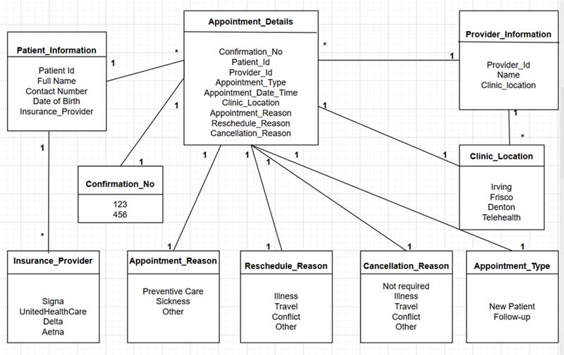
- System Analysis (HW 5)
1. Introduction
For this assignment, we shall apply our skills to design and implement a conversational AI solution for a small healthcare facility using Google Cloud’s Conversational Agents (also known as Dialogflow CX). We intend to create an intelligent conversational AI solution that is capable of scheduling, rescheduling, or even canceling appointments for patients in a natural, human conversation manner using scheduling-related patient care workflows. The solution utilizes natural language processing (NLP) capabilities to empower efficient scheduling-related patient care workflows by combining structured conversation flows, intentions, types, and an accompanying data model to enable an accurate understanding of patient data input for completing scheduling-related patient care operations by the conversational agent.
2. Problem Statement
Smaller clinics may experience challenges in efficiently dealing with large numbers of requests pertaining to appointments. Long wait times, inaccessibility of reception personnel, as well as scheduling/cancelling appointments, create adverse effects in terms of patient satisfaction as well as operations at smaller clinics. A lot of staff time is wasted as they respond to recurring routine questions as well as manually schedule appointments.
From a business perspective, these inefficiencies can lead to:
- Lost revenue from missed appointments,
- Poor patient experience,
- Administrative burnout, and
- Ineffective utilization of provider schedules.
From a technical standpoint, the absence of automation creates bottlenecks. Clinics need a system that:
- Understands patient requests naturally,
- Extracts structured data such as date, time, provider name, and reason for visit, clinic locations
- Verifies sensitive information securely, and
- Updates appointments consistently.
This project solves these problems by creating a conversational AI system that automates key scheduling tasks and interacts with patients 24/7, replacing or augmenting manual scheduling processes.
3. System Requirements Analysis
A. Business Requirements
- Enable patients to schedule appointments independently.
The system should allow users to initiate scheduling through natural language, select providers, choose locations, and view available time slots.
- Support rescheduling and cancellation.
The agent must verify patient identity, fetch existing appointments, and provide alternate options.
- Reduce operational workload.
Automating repetitive administrative tasks frees clinic staff for more complex duties.
- Improve patient experience.
Patients can complete tasks faster, without long wait times or limited office hours.
B. Technical Requirements
- Use GCP Conversational Agents (Dialogflow CX).
Flows, pages, routes, and parameters will structure the conversation and data extraction.
- Design flows such as:
  - Default Start Flow
  - Schedule Appointment Flow
  - Reschedule Appointment Flow
  - Cancel Appointment Flow
- Create intents for:
  - Scheduling
  - Rescheduling
  - Canceling
  - Providing patient details
  - Selecting dates/times
  - Confirming or rejecting system prompts
- Use entity types and entities including:
  - @Patient_Information
  - @Provider_Information
  - @Appointment_Details
  - @Appointment_Type
  - @Appointment_Reason
  - @Clinic_Location
  - @Insurance_Provider
  - @Cancellation_Reason
  - @Reschedule_Reason
  - @Appointment_Date_Time
C. Data Requirements
The conversational agent depends on structured data for accuracy. Required data includes:
- Patient information
(name, DOB, insurance provider, contact method)
- Appointment information
(type, reason, date, time, provider, location)
- Provider information
(name, specialty, clinic location, availability)
- Metadata
(confirmation number, verification method, cancellation/rebooking reasons)

4. Feasibility Analysis
A. Technical Feasibility
Can we complete the project successfully?
Yes. Dialogflow-CX offers all necessary features, including flows, intentions, routes, validation, an adequate data model, as well as team member expertise in NLP, AI agents, and GCP technologies in general.
Technical Risks
- Complex flows may require multiple test iterations.
- Entity misclassification may cause incorrect routing.
B. Business Feasibility
The project provides strong business value:
- Reduces administrative costs by automating scheduling.
- Increases patient satisfaction due to eliminating wait times.
- Ensures 24/7 availability without additional staffing.
Financial Risks
- Clinics may need initial investment in integrating their scheduling system.
- Maintaining cloud resources incurs ongoing costs, though relatively low.
C. Operational Feasibility
Will the system be used by clinics as expected?
Yes. Scheduling is a high-frequency task, and both patients and clinics benefit from automation.
Operational Risks
- Staff training is required to transition to AI-assisted scheduling.
- Patients unfamiliar with technology may need assistance.
- HIPAA compliance must be strictly followed.
6. Conclusion
This project is an example of how conversational AI systems may greatly improve efficiency for small healthcare facilities by automating patient scheduling systems. Even though this project has complex conversation logic and challenging data processing capabilities, it is technically possible, meaning it also contains high business value. As long as teamwork is harmonious, planning is adequate, and GCP conversational agents implement this project in the correct manner, this project should be completed successfully ready to be implemented in real-world settings.

